**Draft**

**Monthly Utilization Entry Procedure.( J2IUN)**

**Purpose-**

**Monthly Utilization Entry through (J2IUN) before 6th of succeeding month.**

**Scope-**

**Monthly Duty Liability Compliance.**

**Responsibility-**

**Utilization Entry done before 6th of succeeding month.**

**Procedure-**

1. After tallying the Duty Liability with Dispatch Team final the Revenue utilization Cenvat Register wise.
2. For Posting the Entry in SAP use T code- J2IUN as given in following screen dump.

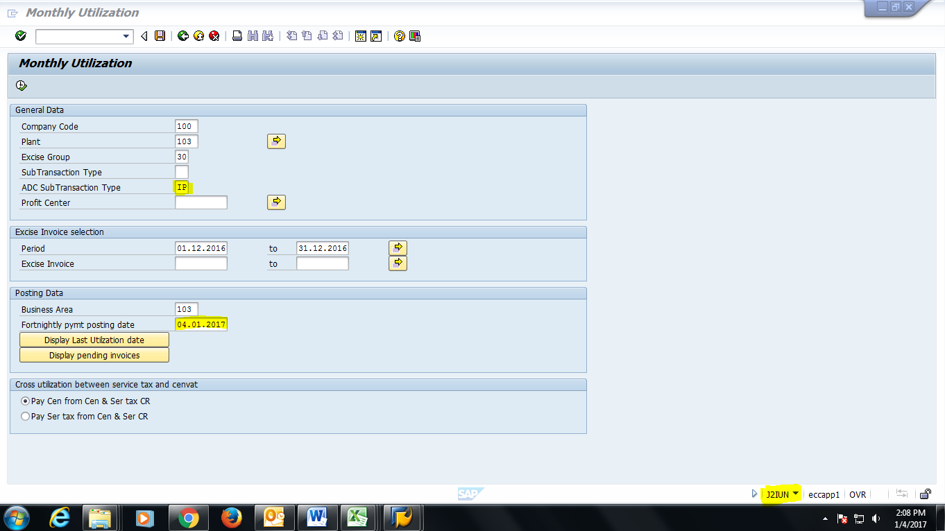

**Then Press Execute & Enter. For following screen.**

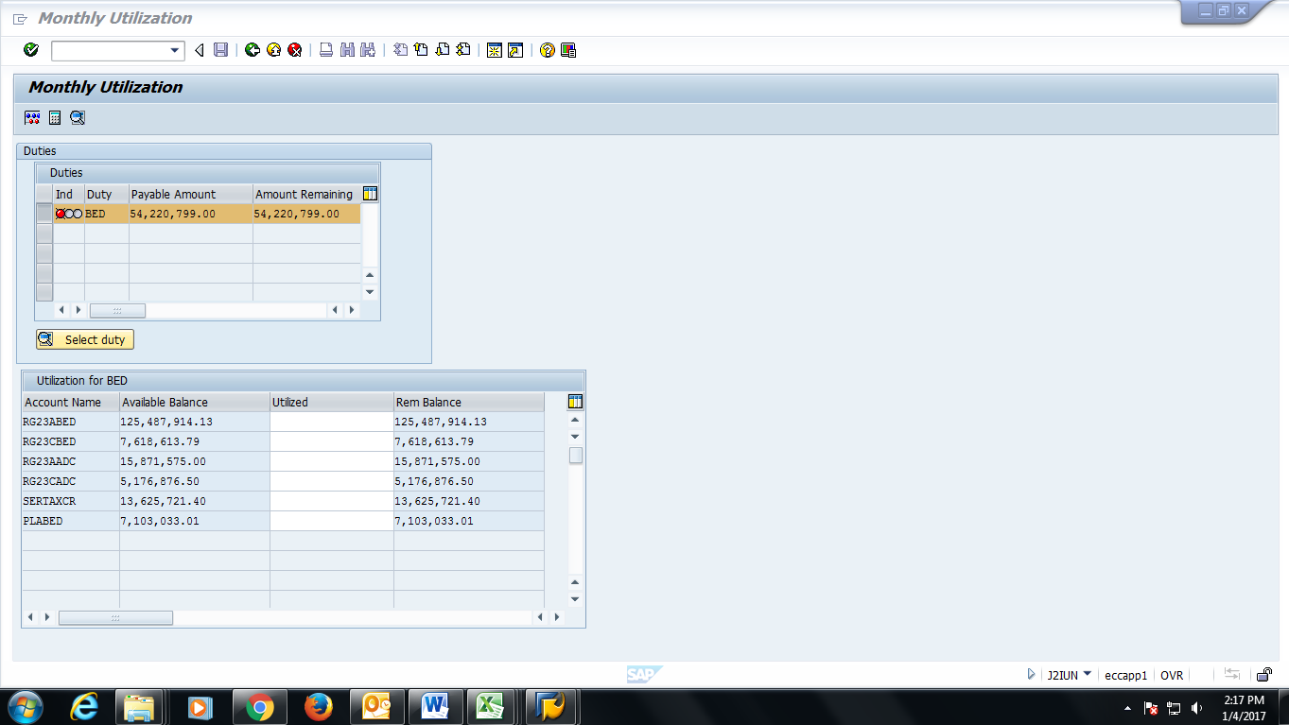

Put the Utilization amount up to sum = monthly Duty Liability in highlighted area. & Simulate

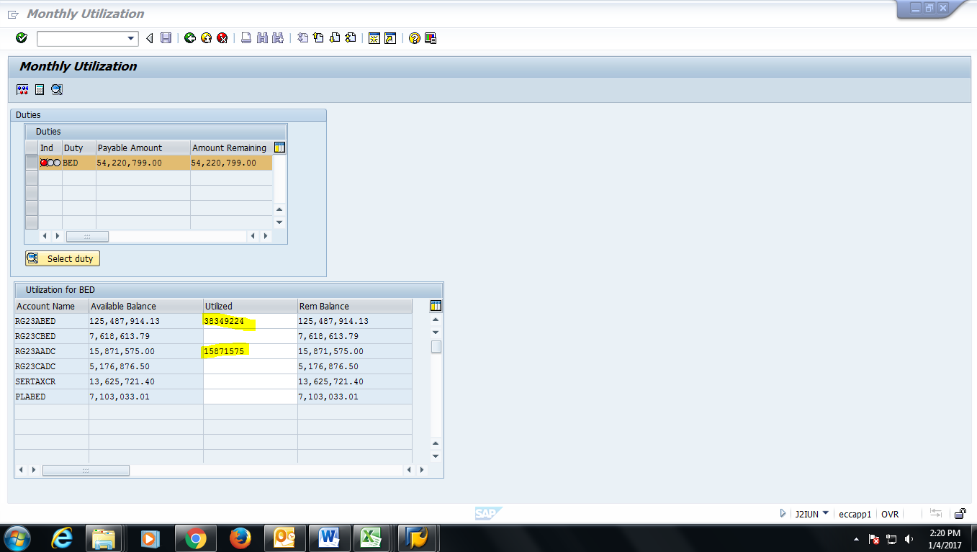

**After simulation confirm the Amount remaining is ZERO. As shown in following screen.**

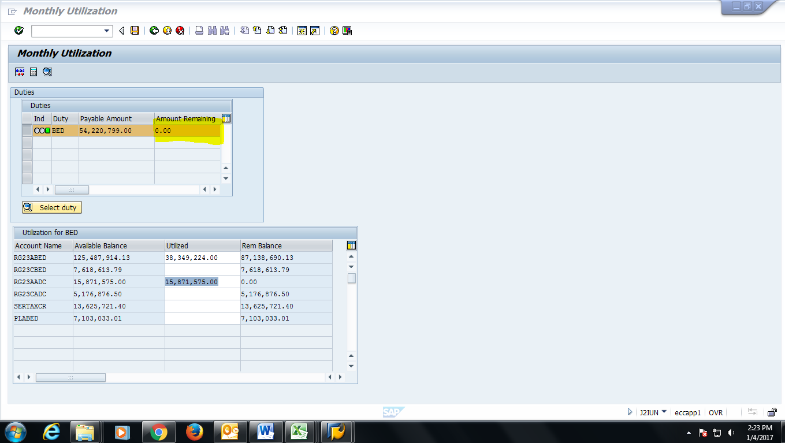

**Save the above screen for Final Utilization of liability.**

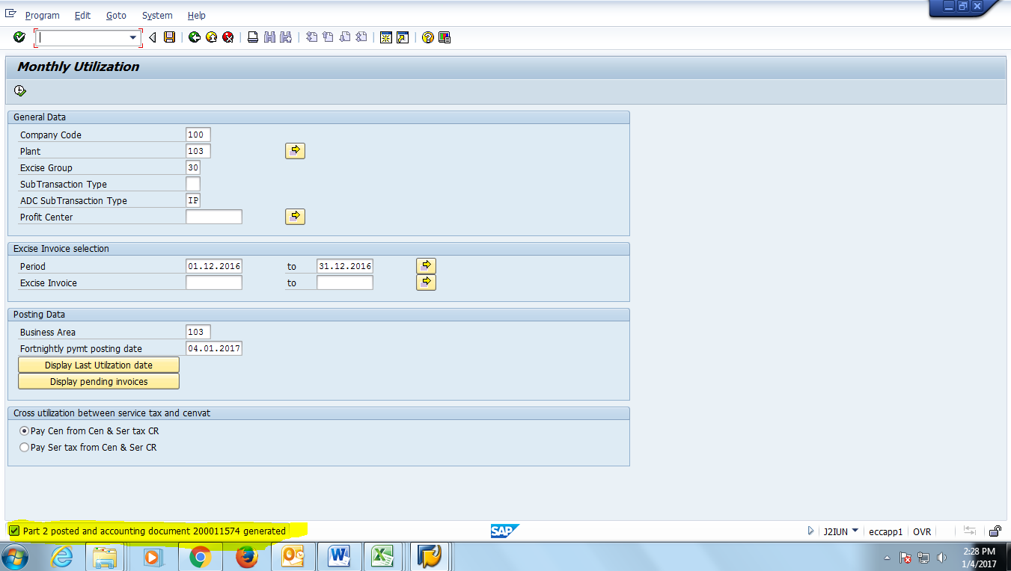

**Note down the highlighted accounting document number. & copy the same in Excel file maintained for Revenue figure.**